 |  | Value3 | Value2 | Value1 |  | Event Name in Event Table | Event Alias
 |  |  |  |  |  | (DTAP) (RR) Immediate Assignment→Timing Advance→Timing Advance Value: 1  (DTAP) (RR) Immediate Assignment→Timing Advance→gsm_a.rr.timing_adv: "1" | Timing Advance
 |  |  |  |  |  | RRC connection Setup→RadioRecourceConfigDedicated→srb-ToAddModList : 1 item | No. of RABs
 |  |  |  | Lte-rrc.transmission mode: 3 | ``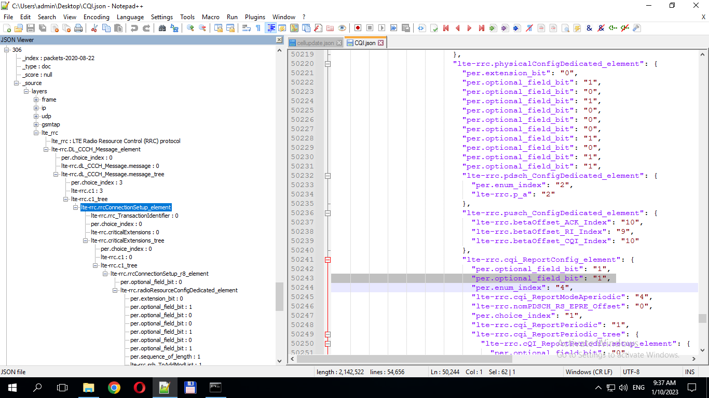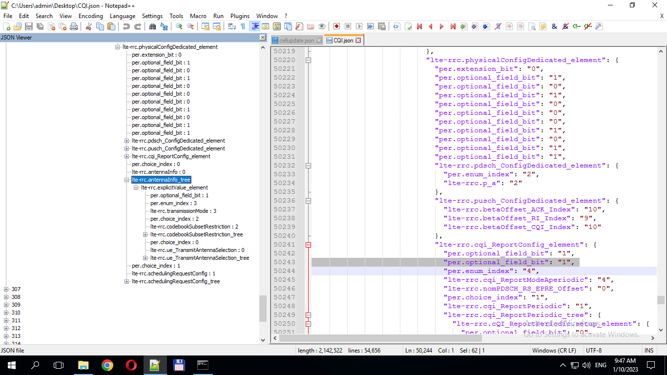 | RRC Antenna Info | Antenna Transmission Mode
 |  |  |  |  |  | Service request | Eps bearer req
 |  |  | lte-rrc.a1_Threshold_tree": "lte-rrc.threshold_RSRQ": "7" | lte-rrc.a1_Threshold": "1" | lte_rrc→ lte-rrc.reportConfigToAddModList_tree→ lte-rrc.eventA1_element | RRC event A1 | A1 event
 |  |  | lte-rrc.a2_Threshold_tree": "lte-rrc.threshold_RSRQ": "1" | lte-rrc.a2_Threshold": "1" | lte_rrc→ lte-rrc.reportConfigToAddModList_tree→ lte-rrc.eventA2_element | RRC event A2 | A2 event (Serving becomes worse than threshold)
lte-rrc.reportInterval": "6" | lte-rrc.reportQuantity": "1" | lte-rrc.triggerQuantity": "1" | lte-rrc.timeToTrigger": "1" | lte-rrc.hysteresis": "2" | lte_rrc→ lte-rrc.reportConfigToAddModList_tree →lte-rrc.eventId_tree | RRC Event hystersis
 |  |  |  |  |  | RRC event A3 | A3 event
 |  |  |  |  |  | RRC event A4 | A4 event
 |  |  |  |  |  | RRC event A5 | A5 event
 |  |  |  |  |  | rrc.eventA6_element | A6 event
 |  |  |  |  |  | rrc.eventB1_element | B1 event
 |  |  |  |  |  | rrc.eventB1-NR_element | B1-NR event
 |  |  |  |  |  | rrc.eventB2_element | Event B2
 |  |  |  |  |  | rrc.eventB2-NR_element | Event B2-NR
 |  |  |  |  |  | Attach Request | PS attach req
 |  |  |  |  |  | Attach Accept | PS attach accept
 |  |  |  |  |  | Activate PDP Context Request | PDP activation req
 |  |  |  |  |  | RadioBearerSetup(ps-domain) | Bearer Setup
 |  |  |  |  |  | RadioBearerSetupComplete | Bearer Setup Complete
 |  |  |  |  |  | Activate PDP Context Accept | PDP activation accept
 |  |  |  |  |  | ActiveSetUpdate | Soft HO request
 |  |  |  |  |  | ActiveSetUpdateComplete | Soft HO accept
 |  |  |  |  | 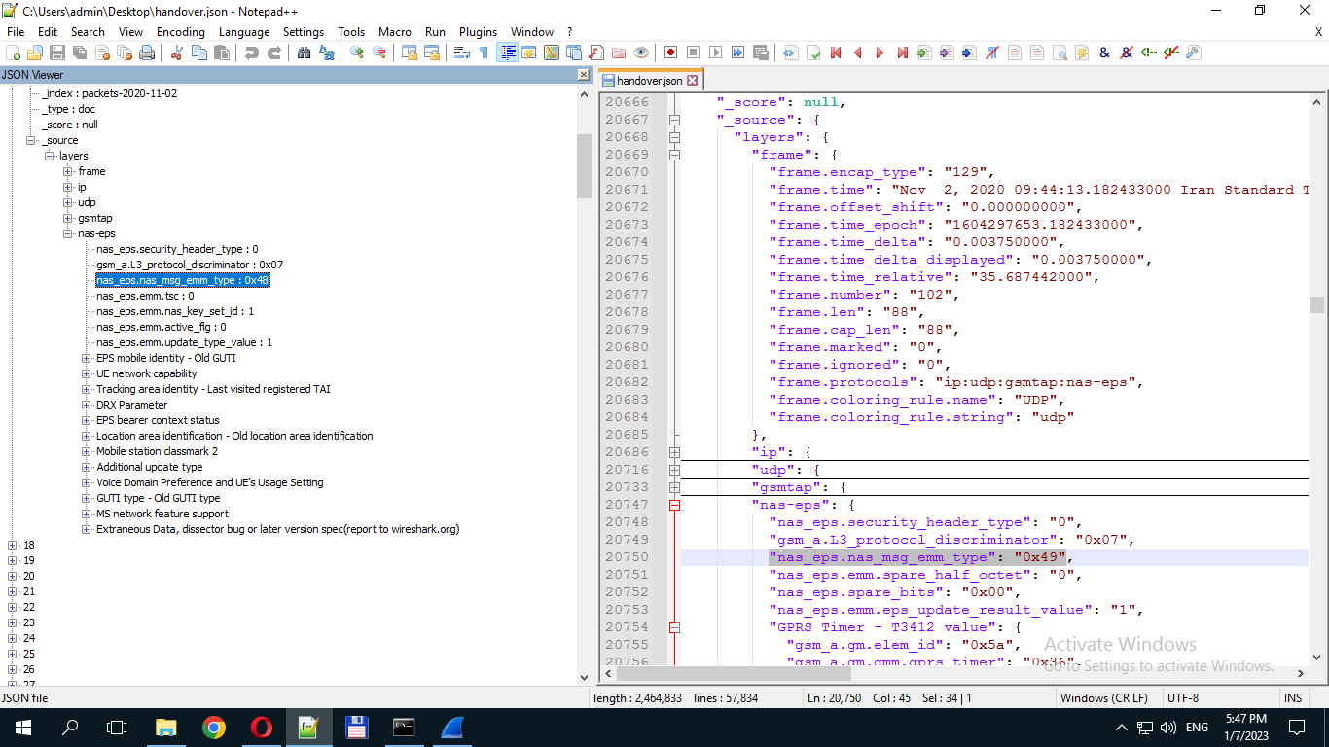 | Tracking area update request | TA update request
 |  |  |  |  | 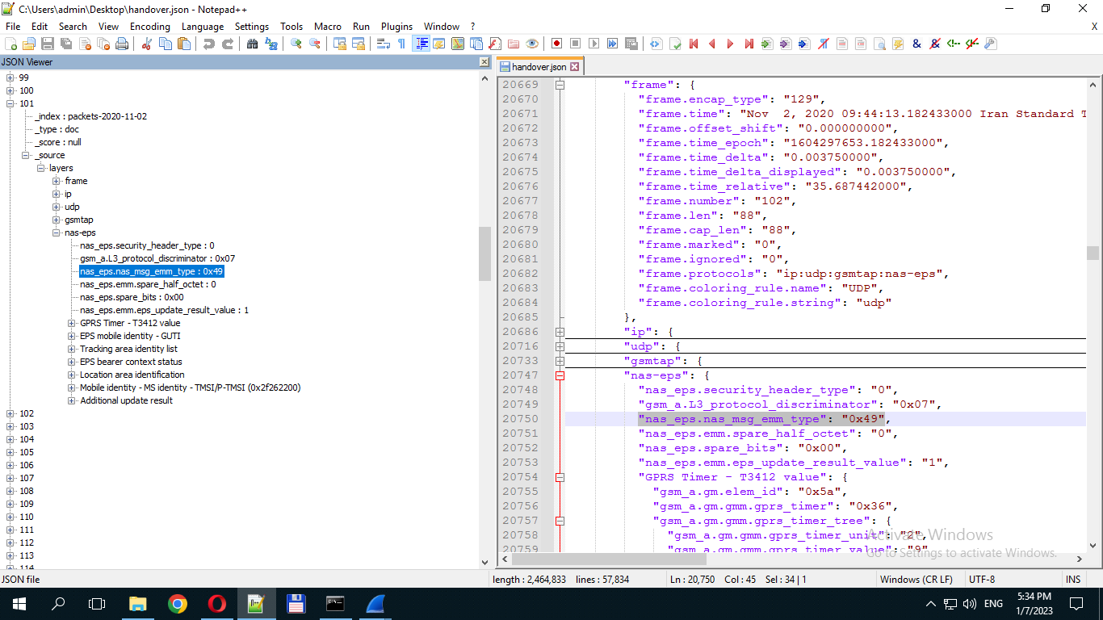 | Tracking area update accept | TA update accept
 |  |  |  |  | 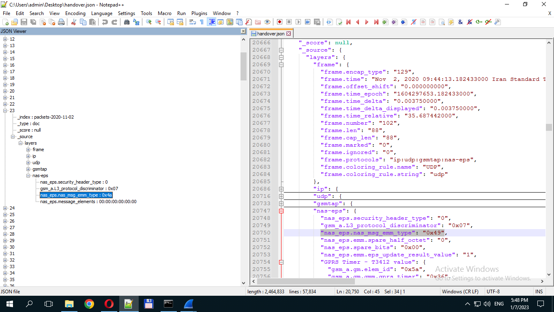 | Tracking area update complete | TA update complete
 |  |  |  |  | 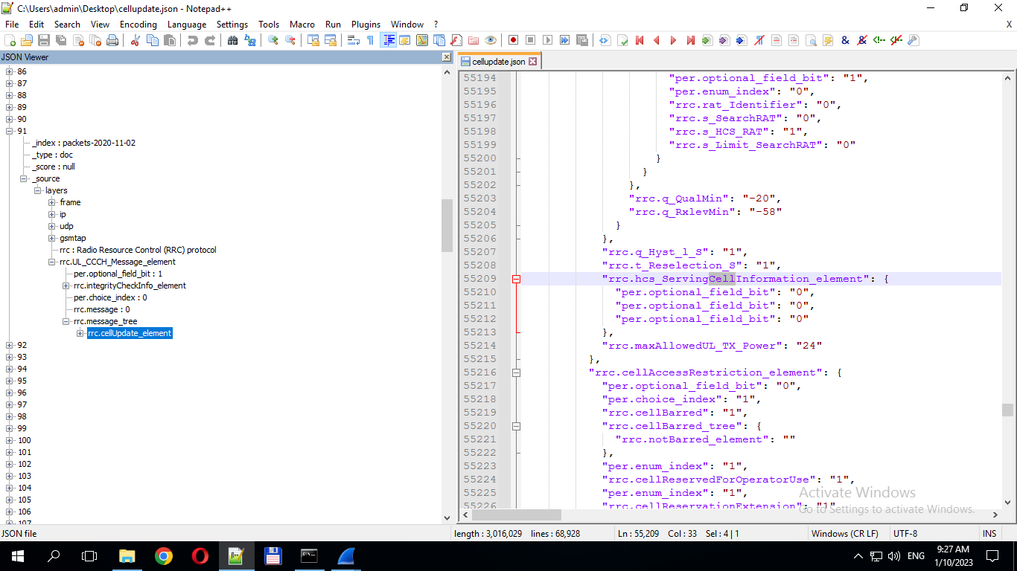 | RRC Cell Update | Cell Update  Request
 |  |  |  |  | 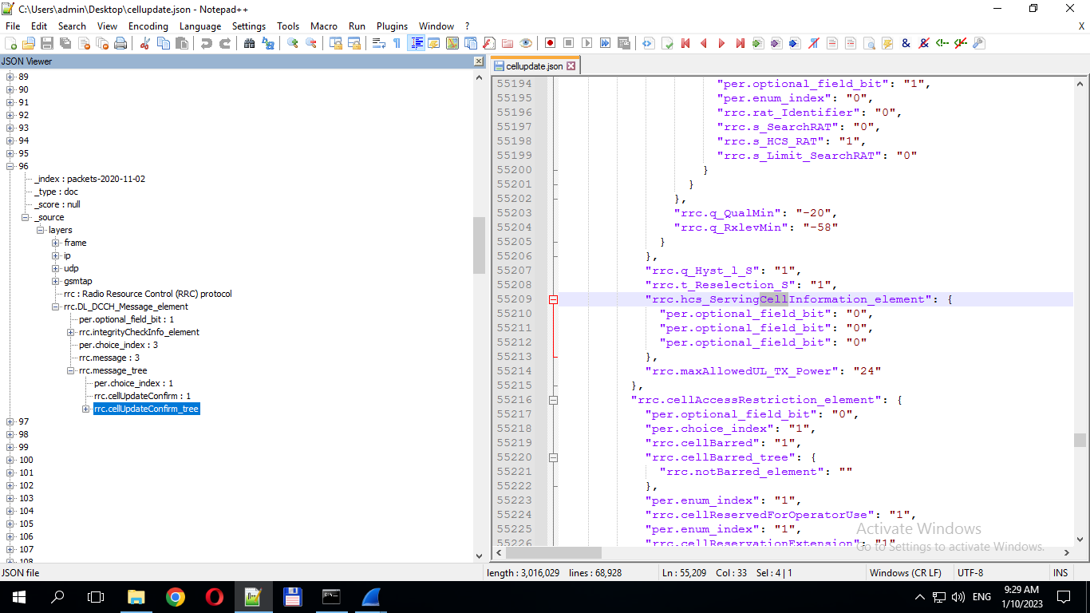 | RRC Cell Update Confirm | Cell Update  Confirm
 |  | lte-rrc.cqi_PUCCH_ResourceIndex": "0" | lte-rrc.cqi_ReportPeriodic": "1" | rrc.cqi_ReportModeAperiodic": "4" | 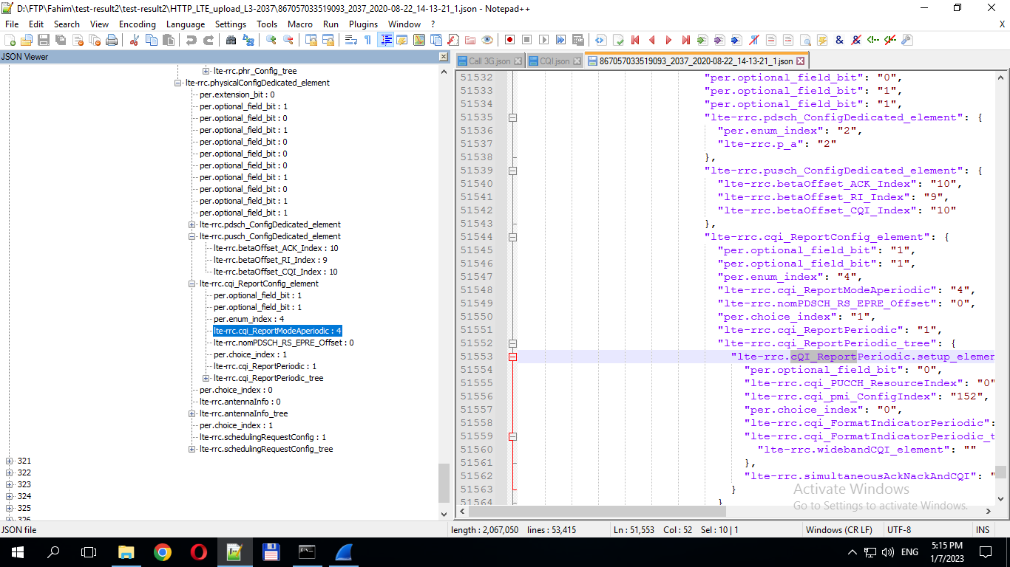 | RRC CQI Report | RRC CQI_Aperiodic
 |  |  |  |  |  | "lte-rrc.cqi_PUCCH_ResourceIndex": "0" | RRC CQI_PUCCH
 |  |  |  |  |  | "rrc.timeToTrigger": "11" | RRC Time to Trigger
 |  |  |  |  |  | "lte-rrc.triggerQuantity": "0" | RRC Trigger Quantity
 |  |  |  |  |  | "lte-rrc.reportInterval": "2" | RRC Report Interval
 |  |  |  |  |  | "lte-rrc.reportAmount": "0" | RRC Report Amount
 |  |  |  |  |  | "lte-rrc.reportQuantity": "1" | RRC Report Quantity
 |  |  |  |  |  | "lte-rrc.hysteresis": "2" | RRC Hysteresis
 |  |  |  | "gsm_a.rr.rxlev_full_serv_cell": "26"  "gsm_a.rr.rxlev_sub_serv_cell": "26"  "gsm_a.rr.rxqual_full_serv_cell": "0"  "gsm_a.rr.rxqual_sub_serv_cell": "0"  Dtx_used : 0 | 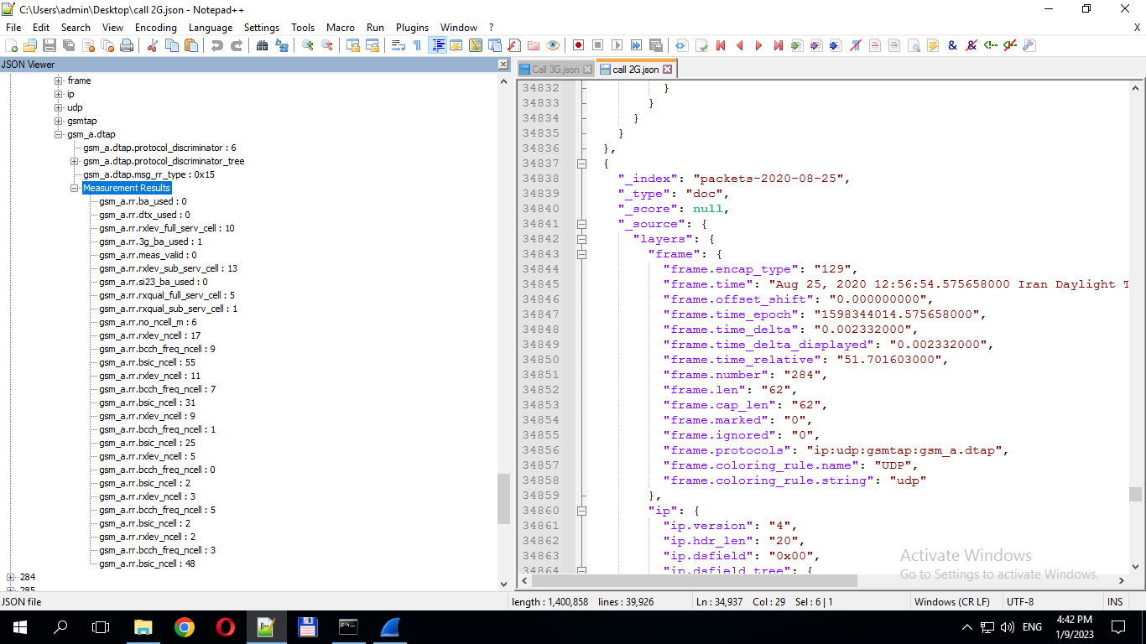 | Measurement Results
 |  |  |  |  | باید برای هر SID لیست codec را بزند : یعنی کلمه بعد .codec را به عنوان فیلد و مقدار 0 یا 1 به عنوان valueآن.  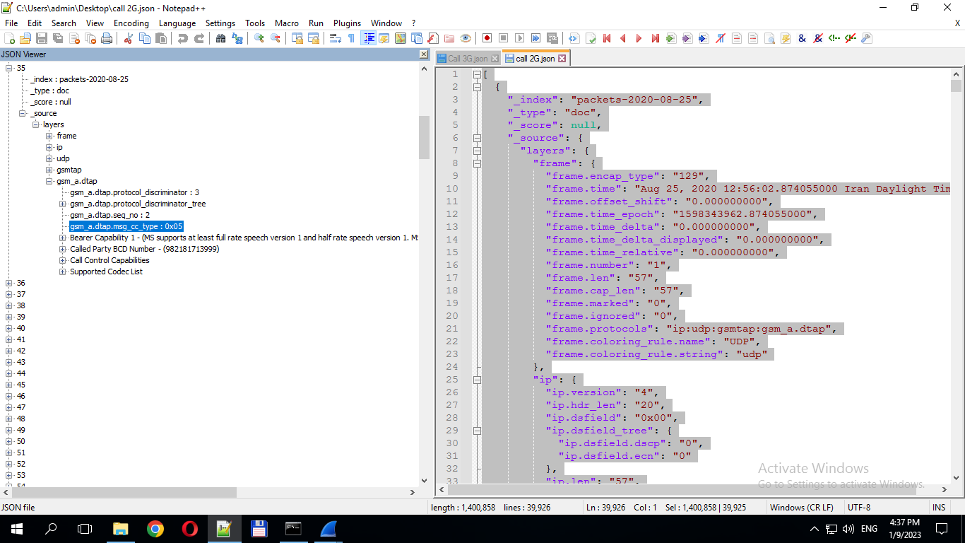  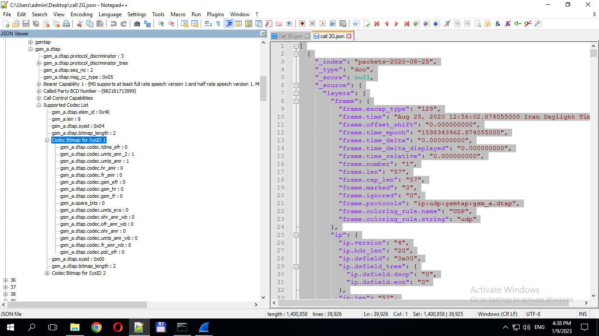 | (DTAP) (CC) Setup→Supported Codec List | Codec List for SysID
 |  |  |  |  |  | (DTAP) (MM) CM Service Request | Call Attemp MO
 |  |  |  |  |  | (DTAP) (RR) Classmark Change | Call Establish
 |  |  |  |  |  | Call (DTAP) (CC) Setup | Call Setup
 |  |  |  |  |  | (DTAP) (CC) Call Confirmed | Call Confirmed
 |  |  |  |  |  | (DTAP) (CC) Call Proceeding | Call Proceeding
 |  |  |  |  |  | (DTAP) (CC) Disconnect | Call Block
 |  |  |  |  |  | (DTAP) (CC) Alerting | Call Alert
 |  |  |  |  |  | (DTAP) (CC) Disconnect | Call Disconnect
 |  |  |  |  |  | (DTAP) (CC) Release | Call Release
 |  |  |  |  |  | (DTAP) (CC) Release | Call Drop
 |  |  |  |  |  | (DTAP) (CC) Release Complete | Call End
 |  |  |  |  | باید برای هر SID لیست codec را بزند : یعنی کلمه بعد .codec را به عنوان فیلد و مقدار 0 یا 1 به عنوان valueآن.  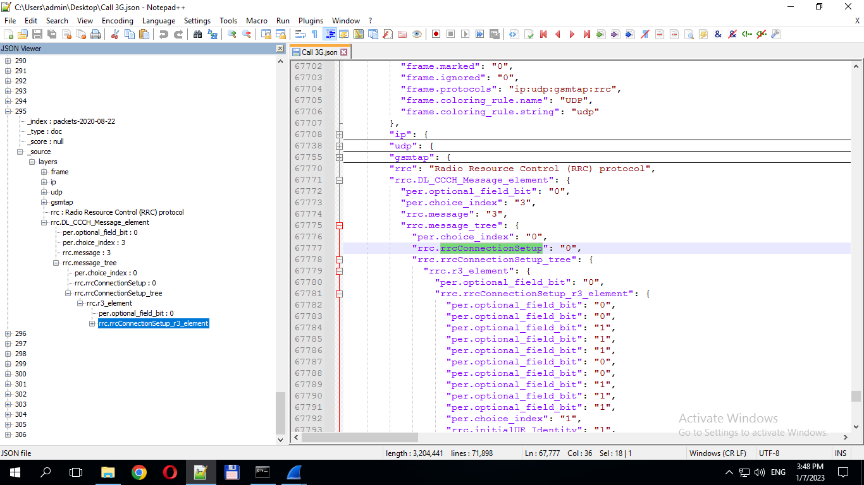  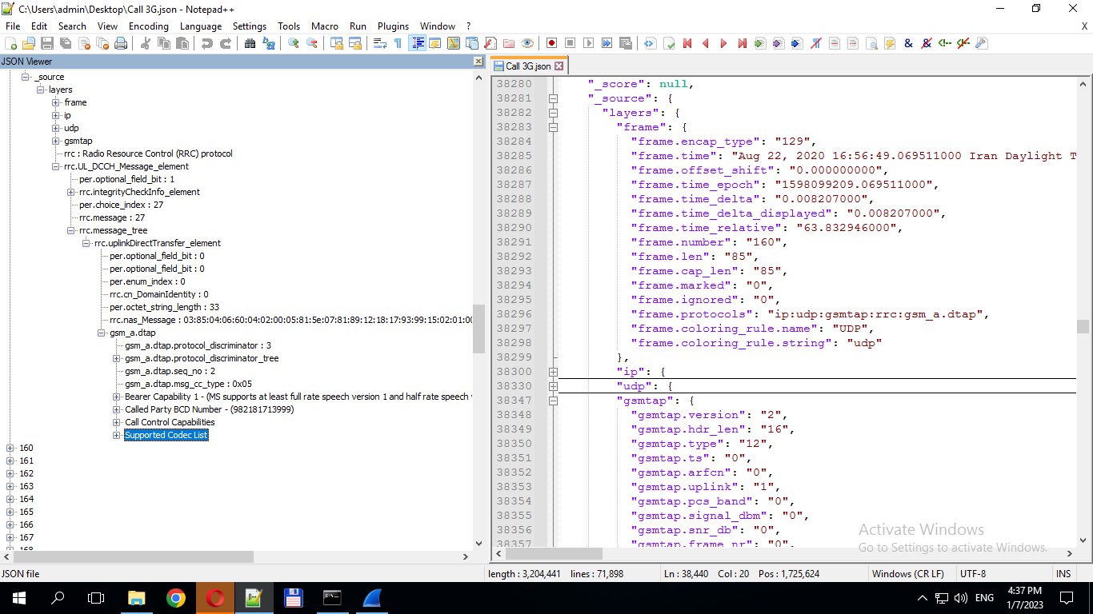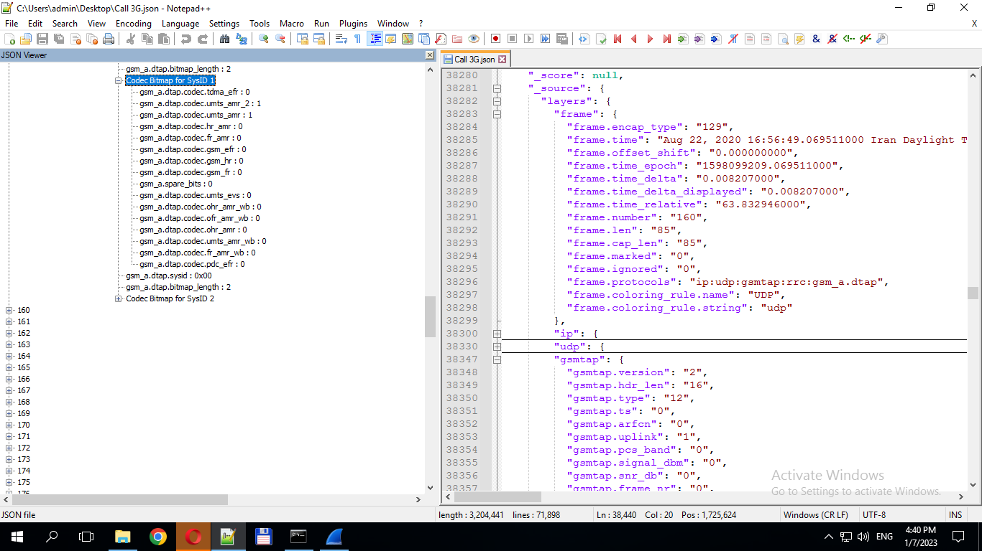 | Supported Codec List | Codec List for SysID
 |  |  |  |  | 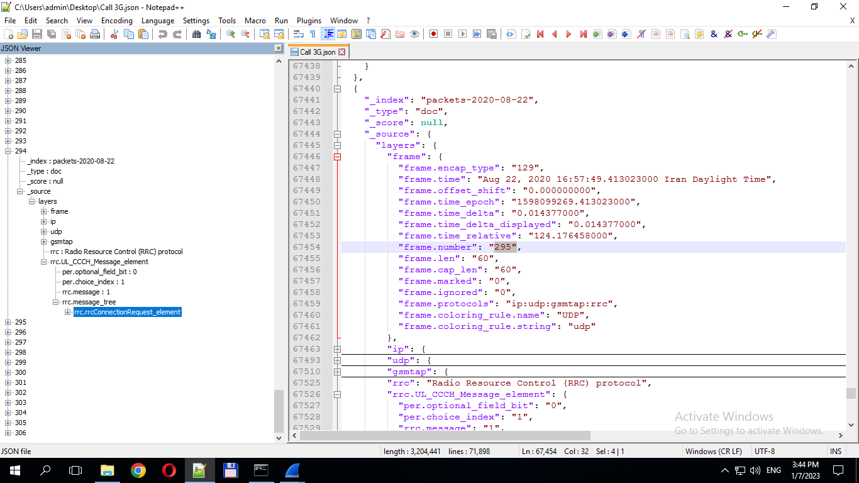 | RRC Connection Request | Call Attempt
 |  |  |  |  |  | RRCConnectionSetup | Call Establish
 |  |  |  |  | 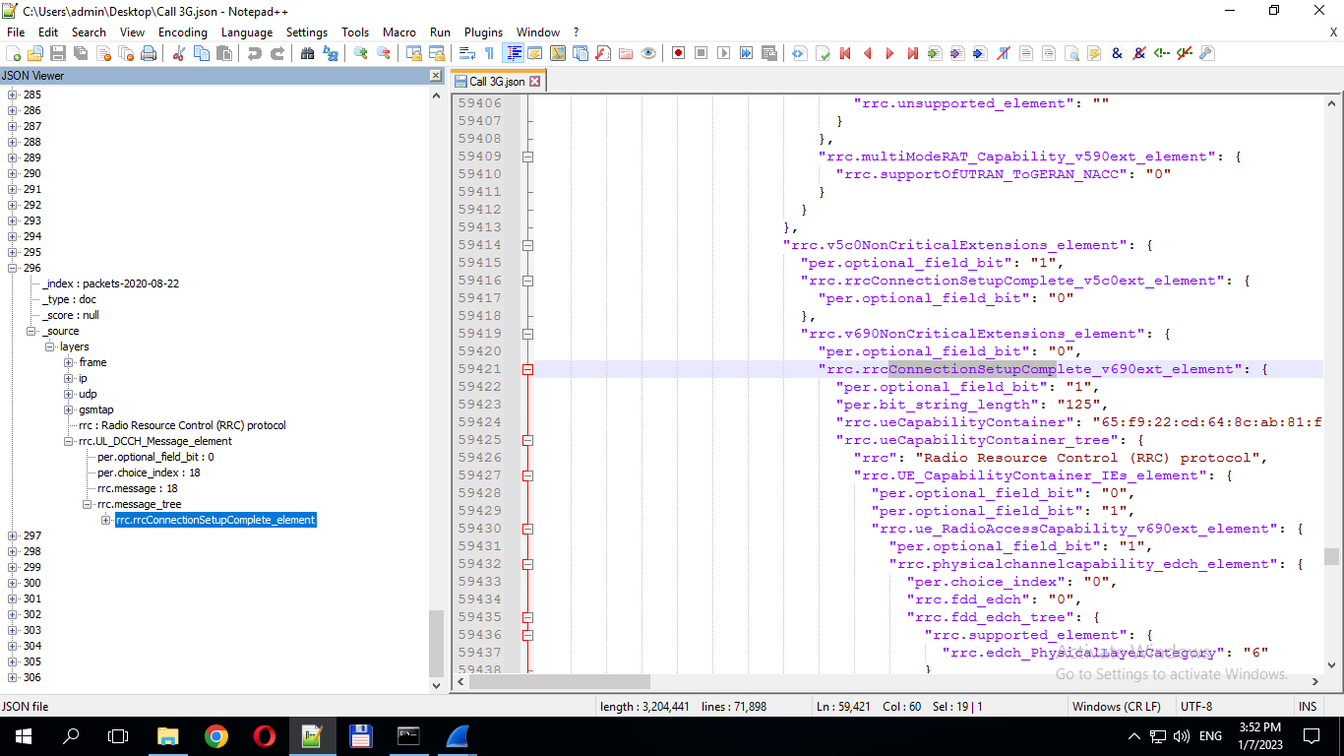 | RRCConnectionSetupComplete(cs-domain)(ps-domain) | Call Initiation
 |  |  |  |  | 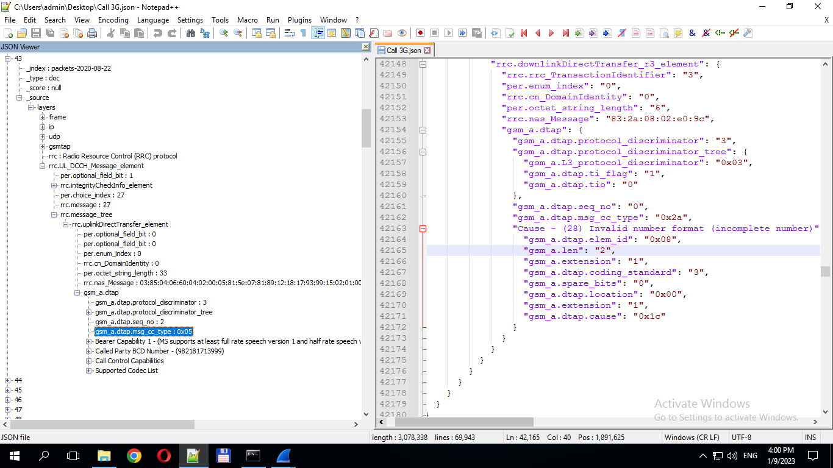 | DownlinkDirectTransfer(cs-domain)(DTAP) (CC) Setup | Call Setup
 |  |  |  |  |  | UplinkDirectTransfer(cs-domain)(DTAP) (CC) Call Confirmed | Call Confirmed (MT)
 |  |  |  |  | 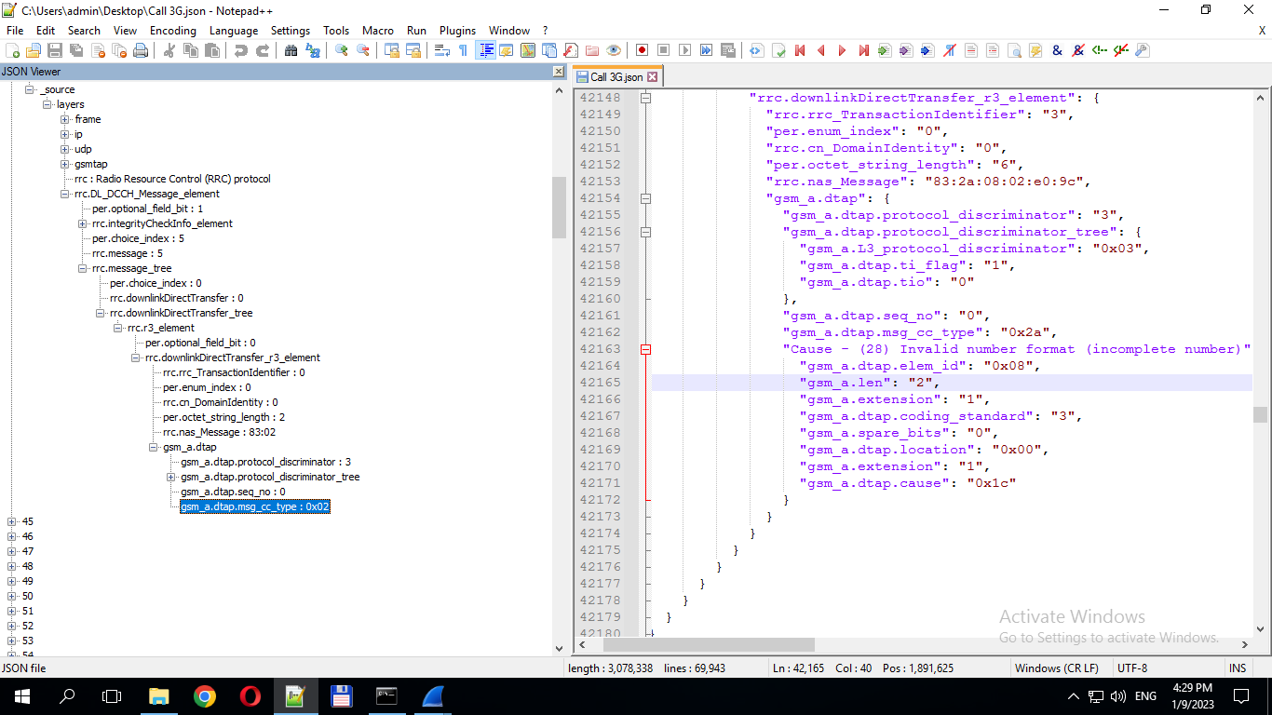 | DownlinkDirectTransfer(cs-domain)(DTAP) (CC) Call Proceeding | Call Proceeding(MO)
 |  |  |  |  | 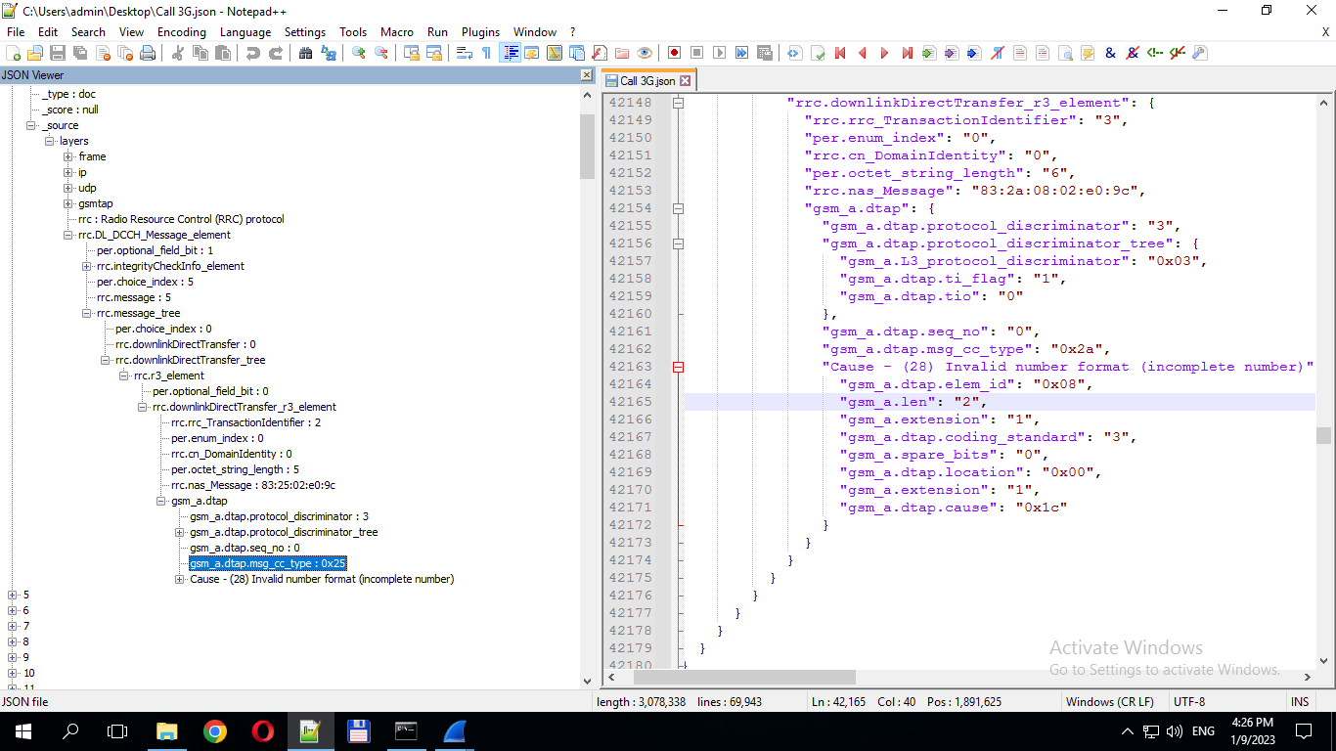 | DownlinkDirectTransfer(cs-domain)(DTAP) (CC) Disconnect | Call Block
 |  |  |  |  | 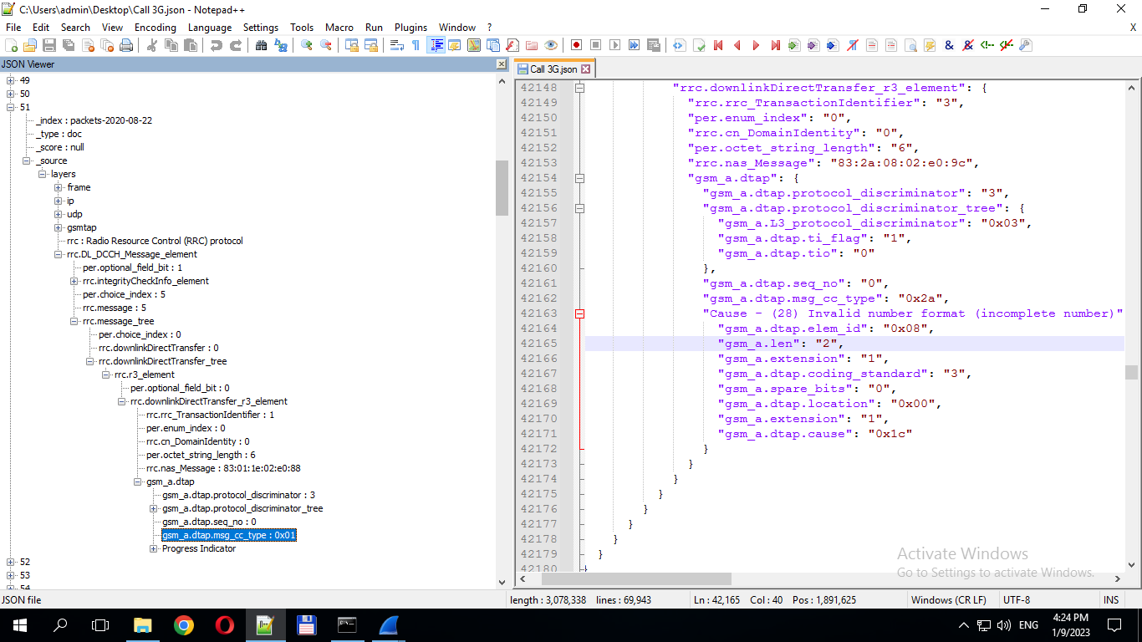 | UplinkDirectTransfer(cs-domain)(DTAP) (CC) Alerting | Call Alert
 |  |  |  |  | 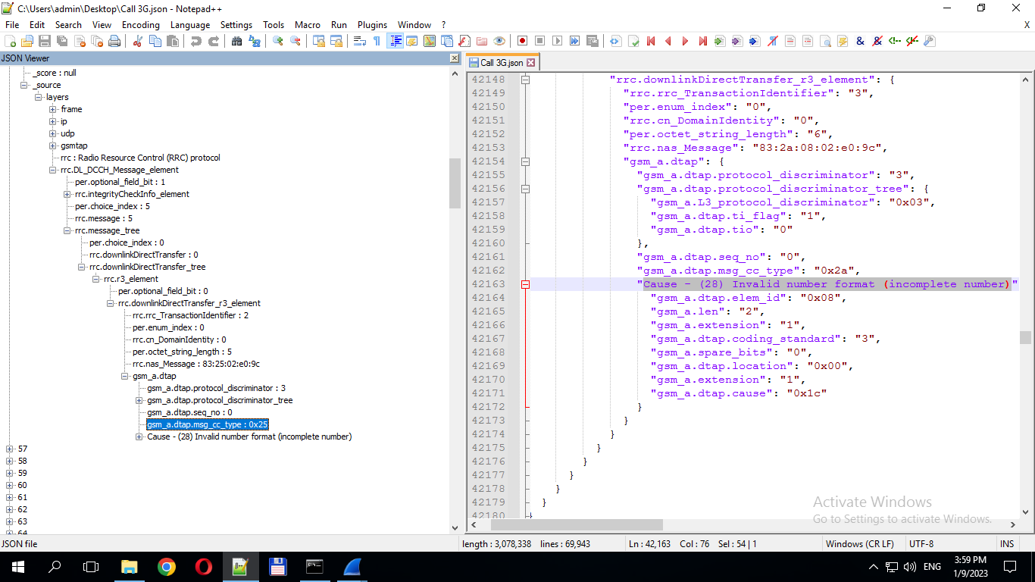 | DownlinkDirectTransfer(cs-domain)(DTAP) (CC) Disconnect | Call Disconnect
 |  |  |  | Rrc.releaseCause : 0 | 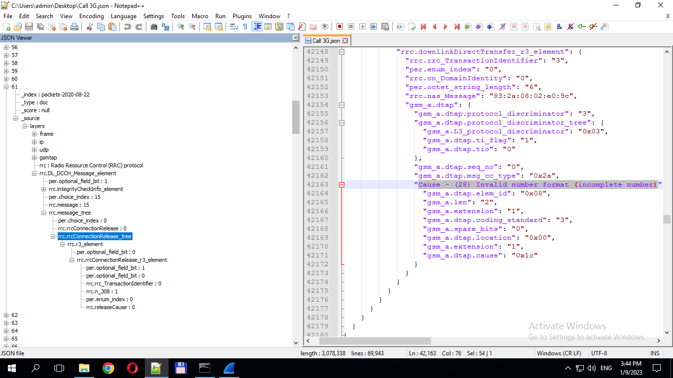 | RRC Normal Connection Release | Call Release
 |  |  |  |  |  | RRC Unnormal Connection Release | Call Drop
 |  |  |  |  | 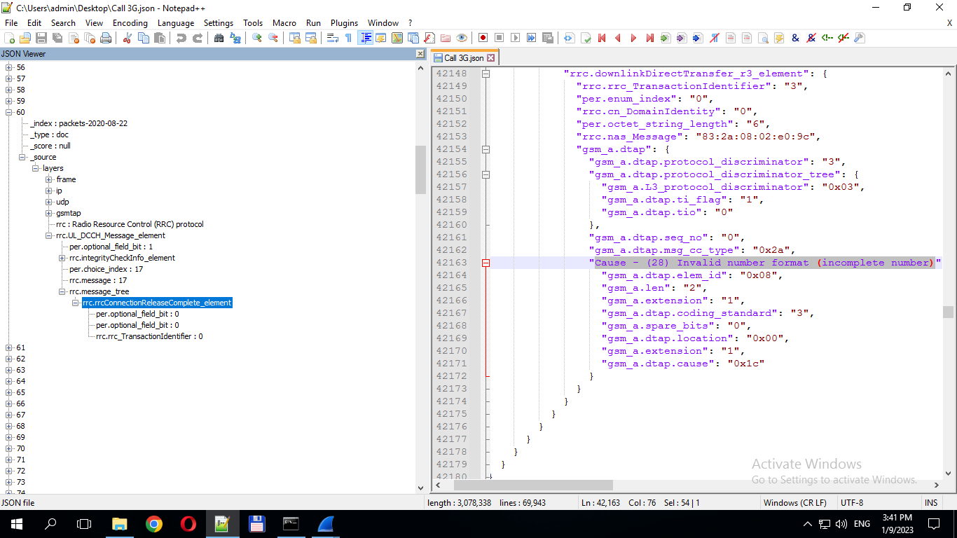 | RRC Release Complete | Call End

